EC2 Instance creation using cloud formation:

<https://docs.aws.amazon.com/AWSCloudFormation/latest/UserGuide/aws-properties-ec2-instance.html#cfn-ec2-instance-securitygroups>

### EC2 Instance:

Type: AWS::EC2::Instance

Properties:

ImageId: *String*

InstanceType: *String*

KeyName: *String*

SecurityGroups:

*-* [*Group details*](https://docs.aws.amazon.com/AWSCloudFormation/latest/UserGuide/aws-properties-ec2-blockdev-mapping.html)

### EC2 Instance Example:

Resources:

MyInstance:

Type: AWS::EC2::Instance

Properties:

ImageId: ami-0470e33cd681b2476

InstanceType: t2.micro

KeyName: 'manman-new-keypair'

SecurityGroups:

- default

----------------------------------------------------------------------------------------------------

### Security Group:

Type: AWS::EC2::SecurityGroup

Properties:

[GroupDescription](https://docs.aws.amazon.com/AWSCloudFormation/latest/UserGuide/aws-properties-ec2-security-group.html#cfn-ec2-securitygroup-groupdescription): *String*

[GroupName](https://docs.aws.amazon.com/AWSCloudFormation/latest/UserGuide/aws-properties-ec2-security-group.html#cfn-ec2-securitygroup-groupname): *String*

[SecurityGroupEgress](https://docs.aws.amazon.com/AWSCloudFormation/latest/UserGuide/aws-properties-ec2-security-group.html#cfn-ec2-securitygroup-securitygroupegress):

*-* [*Egress*](https://docs.aws.amazon.com/AWSCloudFormation/latest/UserGuide/aws-properties-ec2-security-group-rule.html)

[SecurityGroupIngress](https://docs.aws.amazon.com/AWSCloudFormation/latest/UserGuide/aws-properties-ec2-security-group.html#cfn-ec2-securitygroup-securitygroupingress):

*-* [*Ingress*](https://docs.aws.amazon.com/AWSCloudFormation/latest/UserGuide/aws-properties-ec2-security-group-rule-1.html)

[Tags](https://docs.aws.amazon.com/AWSCloudFormation/latest/UserGuide/aws-properties-ec2-security-group.html#cfn-ec2-securitygroup-tags):

*-* [*Tag*](https://docs.aws.amazon.com/AWSCloudFormation/latest/UserGuide/aws-properties-resource-tags.html)

[VpcId](https://docs.aws.amazon.com/AWSCloudFormation/latest/UserGuide/aws-properties-ec2-security-group.html#cfn-ec2-securitygroup-vpcid): *String*

*SecurityGroupIngress / Engress*

[*CidrIp*](https://docs.aws.amazon.com/AWSCloudFormation/latest/UserGuide/aws-properties-ec2-security-group-rule-1.html#cfn-ec2-security-group-rule-cidrip)*: String*

[*Description*](https://docs.aws.amazon.com/AWSCloudFormation/latest/UserGuide/aws-properties-ec2-security-group-rule-1.html#cfn-ec2-security-group-rule-description)*: String*

[*FromPort*](https://docs.aws.amazon.com/AWSCloudFormation/latest/UserGuide/aws-properties-ec2-security-group-rule-1.html#cfn-ec2-security-group-rule-fromport)*: Integer*

[*IpProtocol*](https://docs.aws.amazon.com/AWSCloudFormation/latest/UserGuide/aws-properties-ec2-security-group-rule-1.html#cfn-ec2-security-group-rule-ipprotocol)*: String*

[*ToPort*](https://docs.aws.amazon.com/AWSCloudFormation/latest/UserGuide/aws-properties-ec2-security-group-rule-1.html#cfn-ec2-security-group-rule-toport)*: Integer*

### Security Group Example:

Resources:

MyInstance:

Type: AWS::EC2::Instance

Properties:

ImageId: ami-0470e33cd681b2476

InstanceType: t2.micro

KeyName: 'manman-new-keypair'

SecurityGroups:

- default

- **!Ref** SSHSecurityGroup

SSHSecurityGroup:

Type: AWS::EC2::SecurityGroup

Properties:

GroupDescription: New Security Group

SecurityGroupIngress:

IpProtocol: tcp

FromPort: 22

ToPort: 22

CidrIp: "0.0.0.0/0"

Here !Ref refers to - intrinsic function. Please refer to the below image.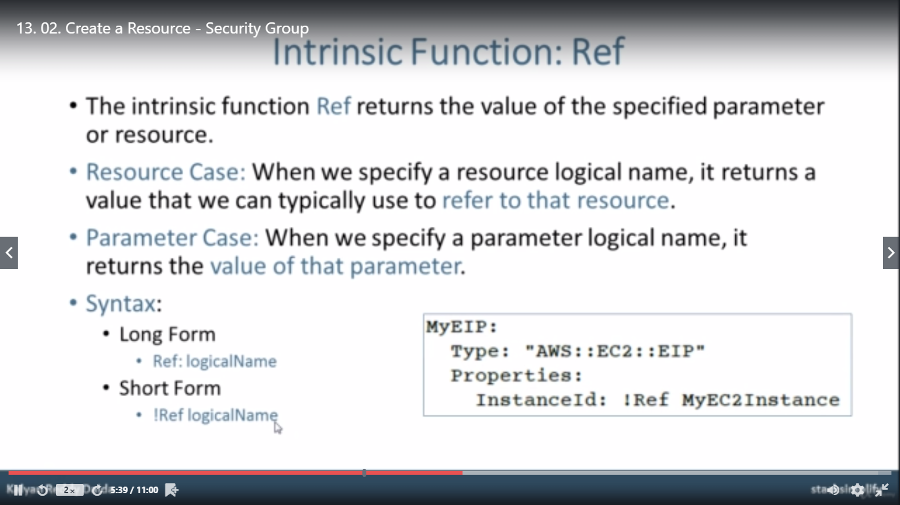

*-----------------------------------------------------------------------------------------------------------------------*

**EC2 Instance with Security Group and Elastic IP:**

### **Syntax**:

**Type: AWS::EC2::EIP**

**Properties:**

[**Domain**](https://docs.aws.amazon.com/AWSCloudFormation/latest/UserGuide/aws-properties-ec2-eip.html#cfn-ec2-eip-domain)**: *String***

[**InstanceId**](https://docs.aws.amazon.com/AWSCloudFormation/latest/UserGuide/aws-properties-ec2-eip.html#cfn-ec2-eip-instanceid)**: *String***

[**PublicIpv4Pool**](https://docs.aws.amazon.com/AWSCloudFormation/latest/UserGuide/aws-properties-ec2-eip.html#cfn-ec2-eip-publicipv4pool)**: *String***

[**Tags**](https://docs.aws.amazon.com/AWSCloudFormation/latest/UserGuide/aws-properties-ec2-eip.html#cfn-ec2-eip-tags)**:**

***-*** [***Tag***](https://docs.aws.amazon.com/AWSCloudFormation/latest/UserGuide/aws-properties-resource-tags.html)

### **Example:**

Resources:

MyInstance:

Type: AWS::EC2::Instance

Properties:

ImageId: ami-0470e33cd681b2476

InstanceType: t2.micro

KeyName: 'manman-new-keypair'

SecurityGroups:

- !Ref SSHSecurityGroup

SSHSecurityGroup:

Type: AWS::EC2::SecurityGroup

Properties:

GroupDescription: New Security Group

SecurityGroupIngress:

- IpProtocol: tcp

FromPort: 22

ToPort: 22

CidrIp: 0.0.0.0/0

- IpProtocol: tcp

FromPort: 8080

ToPort: 8080

CidrIp: 0.0.0.0/0

MyElasticIP:

Type: AWS::EC2::EIP

Properties:

InstanceId: !Ref MyInstance